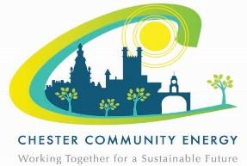
Chester Community Energy

Community Benefit Fund Application Form 2022

Name of Organisation:

Address:

Contact Name:

Tel No:

Email:

Tell us about your organisation. (Maximum 300 words) (Aims, type of service provided, main beneficiaries)

Grant requested [up to a maximum of £2000] £

Existing Project New Project

Tell us about your idea. (How would you use the grant to improve energy efficiency/reduce energy consumption?) It would be helpful if you could give an indication of current energy use and possible savings. Maximum 300 words.

If your project is shortlisted for the second stage of the application process you will be asked to present your idea to a panel.

If required, groups that reach the second stage will be provided with sources of relevant technical information to help with their bid.

Does your organisation have a bank account? | Yes/No (delete as applicable)

I confirm that the information in this application form is correct

Signed ______________________________________

Name ____________________________ Position ________________________

DEADLINE: Stage 1 applications must be submitted by 5.00pm on Friday 17th December 2021.

To be returned to Cheshire West Voluntary Action joanne.stanton@chesterva.org.uk

